|  |
| --- |
|  |
| Smart Green House Effect  LINEAR CONTROL SYSTEM PROJECT |
| |  |  |  | | --- | --- | --- | | DR. LUBNA FARHI | ELECTRONIC ENGINEERING DEPARTMENT | SIR SYED UNIVERSITY OF ENGINEERING & TECHNOLOGY | |

**SMART GREEN HOUSE**

**MONITORING & CONTROL SYSTEM**

**LINEAR CONTROL SYSTEM (EE_340)**

**Submitted by**

**MUHAMMAD HASSAN 2017-EE-069 AAZIB AHMED ANSARI 2017-EE-078**

**MIRZA HAMZA UMER 2017-EE-079**

**MUAMMAD USMAN 2017-EE-107**



**6th Semester Project Report**

Department of Electronic Engineering

Sir Syed University Of Engineering and Technology, Karachi

**ACKNOWLEDGEMENT**

We would like to express our deepest appreciation to all those who provided us the possibility to complete this project and report.  A special gratitude we give to our project  teacher, **Dr. LUBNA FARHI,** whose contribution in stimulating suggestions and encouragement,  helped me to coordinate our project especially in writing this report.

Furthermore we would also like to acknowledge with much appreciation the crucial role of **Miss Rumaisa** and **Miss Hira** who gave the guidance to in our project and the necessary materials to complete the project. A special thanks goes to my Group Members who  help me to assemble the parts and gave suggestion about the task .Last but not least, many thanks go to the head of the project, whose have invested his full effort in guiding the team in achieving the goal. I have to appreciate the guidance given by other supervisor as well as the panels especially in our project presentation that has improved our presentation skills thanks to their comment and advices.

**TABLE OF CONTENTS**

**Page**

**Acknowledgment** 02

**Table of Contents** 03

**List of Figures**  04

**List of Tables** 04

**Abstract** 05

1. **INTRODUCTION**

1.1 Introduction 05

1.2 Green House Effect 05

1.3 Problems and Solutions 06

1.4 Theoretical Background 06

1. **PROJECT BLOCK DIAGRAM**

2.1 Block Diagram 07

2.2 Description of Blocks 08

2.3 Design specification 09

1. **METHODOLOGY**

3.1 Hardware Working 10

3.2 Software Working 10

1. **TESTING**
   1. Hardware Testing 10
   2. Software Testing 11
2. **OBSERVATIONS & RESULTS** 11
3. **CONCLUSION & FUTURE RECOMMENDATION** 12

**REFRENCES** 13

**APPENDIX A: Cost Analysis of the Project** 14

**LIST OF FIGURES**

**Page**

Figure 1.1 Green House Effect  06

Figure 2.1 Block Diagram of Circuit 07

Figure 2.2 Pin Configurations 08

Figure 2.3 Pictures of some sensors 09

Figure 5.1 Observations & Results 11

**LIST OF TABLES**

**Page**

Table 1.1 Threshold Values  07

**ABSTRACT**

This Project represents the need of Greenhouse and how much effective they can be in good yield of crops. As plant grows, they need certain environmental parameters for its proper growth like humidity, temperature, light. Also, Automated Greenhouse Monitoring ignores the need of human operators to take care of the plants. To monitor the Greenhouse parameters like temperature, soil moisture and light properly, a control system is needed. This control system is comprised of greenhouse data acquisition OP amp based PID system along with temperature, and light. For monitoring and storing the values of these environmental parameters based circuit is used. Based on the values stored, the above system will compare the stored values with threshold values set for particular plant and control the actions of cooler, heater, and water pump. Greenhouse monitoring and control software can collect, values of various parameters, also can control greenhouse environment. For indication of system , we have used RED & GREEN LED’s. This system is very useful for proper cultivation and maximum yield of crops.

**INTRODUCTION**

* 1. **Introduction:**

A greenhouse is a building in which plants are grown for commercial or research purposes. These structures range in size from small sheds to very large buildings, with different types of covering materials, such as a glass or plastic roof and frequently glass or plastic walls. But, nowadays, the rising demands for crop production and quality have significantly increased the utilization of high quality and productivity of greenhouse.

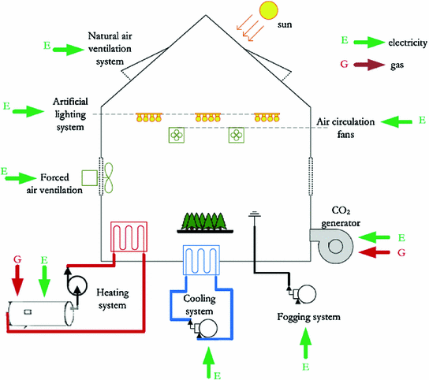

**FIGURE 1.1 GREEN HOUSE EFFECT**

The proposed system is an embedded system which will monitor and control the microclimatic parameters of a greenhouse on a regular basis round the clock for cultivate

on of crops or specific plant species which could maximize their production over the whole crop growth season and to eliminate the difficulties involved in the system by reducing human intervention to the best possible extent using sensors. When any of the above mentioned climatic parameters cross a safety threshold which has to be maintained to protect the crops, the sensors sense the change and the PID reads error and then try to make it stable again. The PID algorithms then performs the needed actions by employing relays until the strayed-out parameter has been brought back to its optimum level. Since a PID is used as the heart of the system, it makes the set-up low-cost and effective nevertheless. As the system also employs a LED’S display for continuously alerting the user about the condition inside the greenhouse, the entire set-up becomes user friendly.

**1.2 Problem and Solution Encountered On Green House**:

Irrigation is the important thing on a greenhouse system. The water we provide, which is the main element will make sure the plants survive on certain circumstances. As we all know, most of the gardener use the manual system to irrigate their plant but this system is not efficient. The plants will either die if there is not enough water supplies to the plant or vice versa. Plus the gardener must often monitor their greenhouse to ensure the conditions of their plant are in the good health. In order to maintain the condition and overcome the problem, the automatic watering system and remote monitoring is used. This will reduce the time if using automatic rather than manual way of watering. Fewer workers are needed to maintain the plants or crops. The sensors such as temperature sensor (Thermistor) and soil moisture probe are used to control the temperature and watering in the greenhouse.

* 1. **Theoretical Background:**

The greenhouse system is complex system; any significant change in one climate parameter could have an adverse effect on another climate parameter as well as the development process of plants. Therefore continuous monitoring and control of these parameters is required for the proper growth of plants. Temperature, light intensity, soil moisture are the most common factors that most growers pay attention to. So now a day’s farmers require more user friendly platform to deal with issues that arise due to climate changes. Previous researchers have used sensors such as leaf temperature and leaf wetness sensor in conjunction with ambient temperature sensor and humidity sensors to investigate greenhouse’s status.

**TABLE 1.1 THRESHOLD VALUES:**

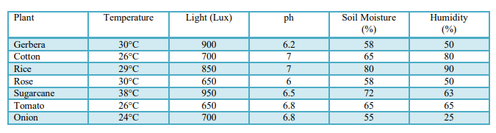

These methods were found to be impractical as wetness varies from leaf to leaf and by location of plant in greenhouse. In general the greenhouse system can be divided into two main components that interact in more or less strong way: internal atmosphere and soil conditions. Most of the growers and researches are interested in internal atmosphere of greenhouse and often neglect the importance of soil conditions. The absorption and transportation of water and nutrients are dependent on the condition of soil. Therefore it is very essential to maintain the temperature and moisture level in the soil at an optimum level in order to keep the plant healthy.

**PROJECT BLOCK DIAGRAM**

* 1. **Block Diagram:**

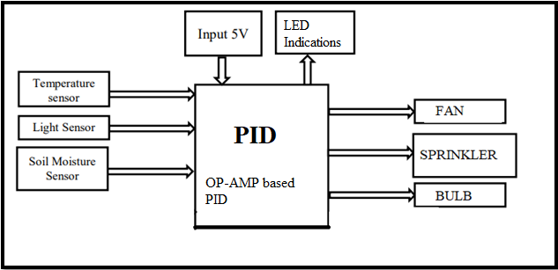

**FIGURE 2.1 Block Diagram of the circuit**

**2.2 Description of Blocks:**

**HARDWARE DESCRIPTION**

1. **PID**

PIDs are used in automatically controlled devices. For Greenhouse effective management, here in our project.

1. **Sensor:**

Sensor is a device which is used to convert physical quantity into electrical signal. A sensor is a device, which responds to an input quantity by generating a functionally related output usually in the form of an electrical or optical signal.

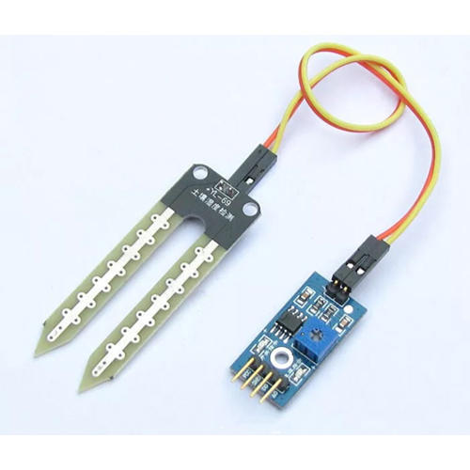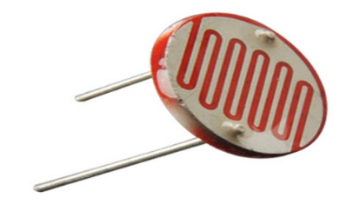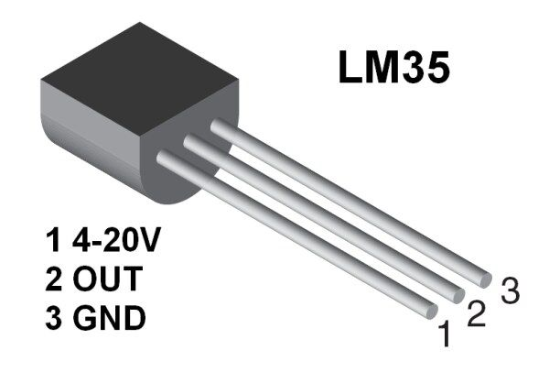**LIGHT Sensor (LDR) Temperature Sensor (LM35) Soil Moisture Sensor (FC-28-D)**

**FIGURE 2.3 PICTURES OF SENSORS**

**2.3 Design Specifications:**

**Input side - Sensors:**

1) Temperature (LM35D)

2) Light (LDR)

3) Soil Moisture (FC-28-D)

**Output side - Relays**

• Lower Temperature & decrease humidity: Cooling Fan

• Relay: Raise temperature: TUNGSTAN- bulb

• Increase lighting condition: Light-bulb

• Sprinkler for increase in soil moisture.

• Constant monitoring through LED’S

**METHODOLOGY**

**3.1 HARDWARE WORKING(Controlling):**

Analog PID Control Using Op-Amps:

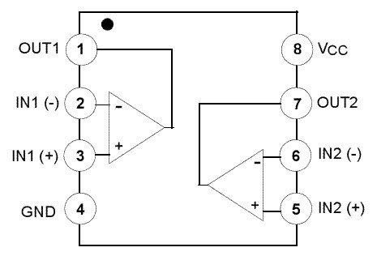The op amps LM 358 that were used for this setup consisted of two op amps in one unit. Hence 3 of them were used to construct the required circuit that uses five op amps. The circuit was then built with utmost precision. Output of every individual circuit namely Integrator, Derivative, Proportional and Summing were taken using the oscilloscope to see the conformity with the expected results.

1. **Inverting Op-Amp:**

 The primary function of inverting Op-Amp is to amplify the input voltage to output voltage. It connects the positive input terminal to ground, and input signal is connected to the negative input terminal. There are two resistors around the op-amp: Ri and Rf. The gain of the inverting op-amp is given by

                                                                 KCL = −Rf/Ri

1. **Non-inverting Op-Amp:**

 The functionality of non-inverting amplifier is to simply amplify an input voltage to output voltage with a positive gain. This is accomplished by the feedback connections. The gain of the non-inverting op-amp is always greater than 1.

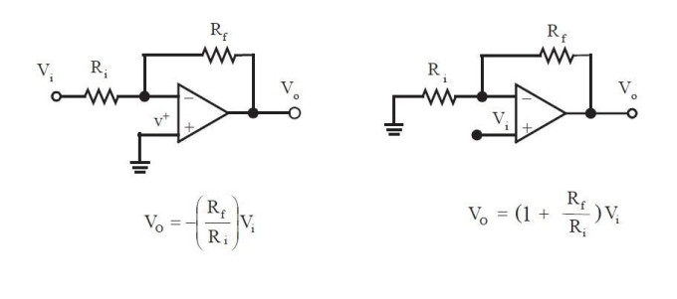

1. **Derivative Op-Amp:**

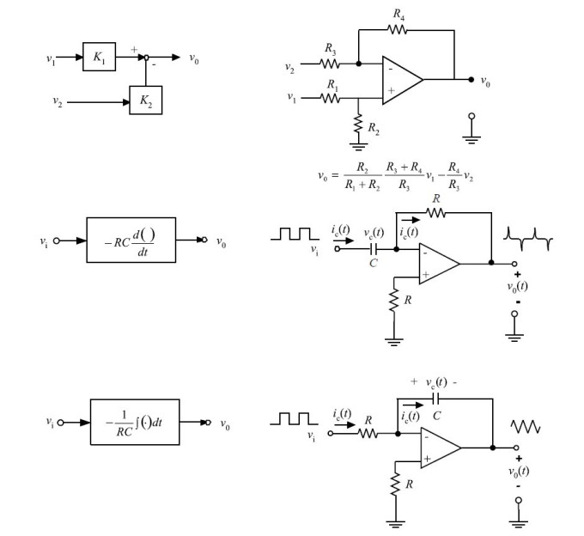The derivative Op-amp takes the derivative of the input voltage signal and provides that as output voltage signal.

1. **Integrating Op-Amp:**

The integrating op-amp circuit is obtained by changing the locations of the resistor and capacitor in the derivative op-amp circuit. I

ntegral op-amp circuit typically includes a parallel resistor with the capacitor. The reason for that is that a “pure” integrator adds a −90 degree phase (phase lag) to the loop at all frequencies. If we could reduce that phase lag at least at lower frequencies, it would improve the stability of the closed loop system. Hence, a pure integrator may be modified with a resistor R2 in parallel with the capacitor in the feedback path to accomplish this.

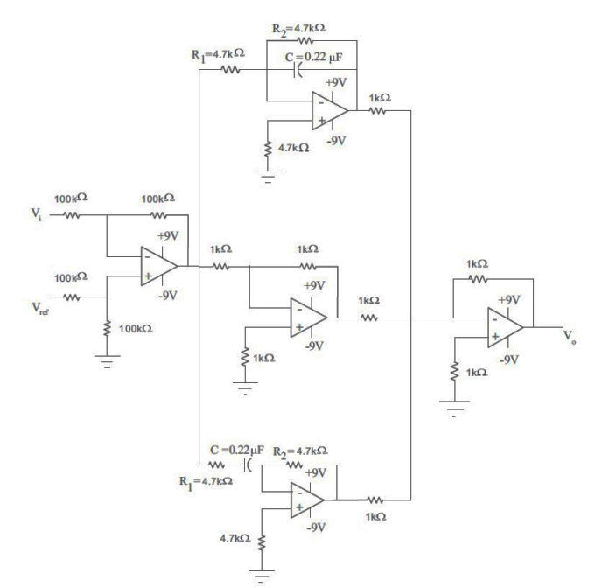Now Combining all of the above 3 circuits using a summer/comparator we have:

Now the results of the oscilloscope from the virtual simulation through proteus whwn we provided a sine wave at its input:

1. **Proportional circuit:** The output resembles the input only to be amplified by the gain of the circuit.
2. **Derivative Circuit**: This Circuit produces a voltage output which is directly proportional to the input voltage’s rate-of-change with respect to time i.e. the faster or larger the change to the input voltage signal.
3. **Integrator Circuit:** On applying sine wave at input of an Integrator Amplifier then the capacitor will charge and discharge in response to changes in the input signal. This results in the output signal being that of a triangular waveform.
4. 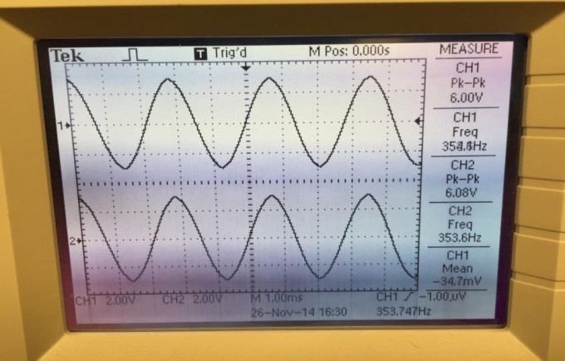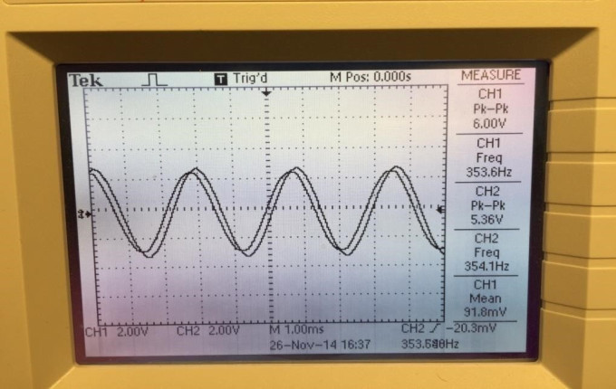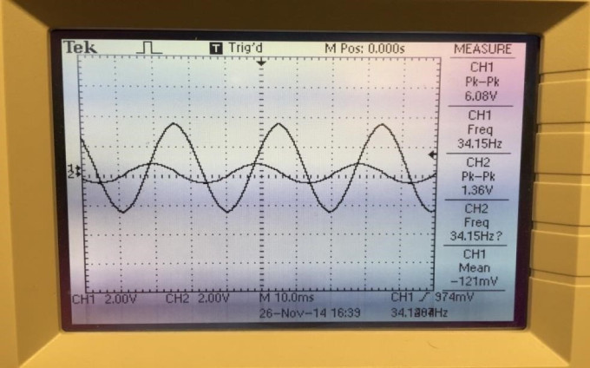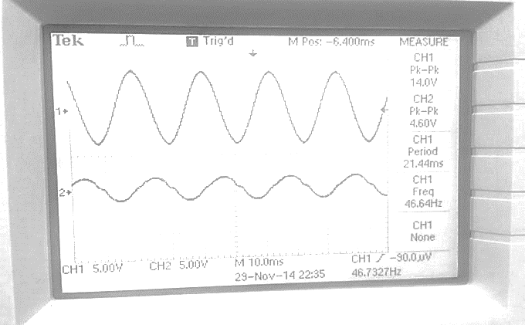**PID Circuitory:** On summing all of the above amplifier circuits the PID is formed and makes the system stable as by attenuating the signal which is with noise and distortion. The summing op amp induces all the individual features to provide controller action. The **proportional:** providing an overall control action proportional to the error signal through the all pass gain factor. The **integral**: reducing steady state errors through low frequency compensation by an integrator. The **derivative**: improving transient response through high frequency compensation by a differentiator.
5. **TESTING**

**4.1 Software Testing:** In Software testing, we used Proteus 8 for virtual simulation of various sensors with respect to the op amp based PID. Proteus is very user friendly electronic circuit design software which can be used for circuit design, virtual simulation . We interfaced the sensors with the controller, to observe the monitoring and control actions. According to the thresholds set by the help of resistors we observed the related control actions that should have taken place in real time.

* 1. **Hardware Testing:** In hardware testing we opted for breadboard .In breadboard testing we checked the power supply output, all the results were positive and we got 5V at the output. We interfaced 3 sensors namely temperature (LM35), LDR and soil moisture (FC-28-D) on breadboard with OP-AMPS to check the monitoring and control actions. For testing purpose we used LED’s to detect whether the control actions are being performed correctly or not. The results that we achieved from breadboard testing were satisfactory and convincing. Whenever the temperature went beyond the predefined threshold range, the (RED) LED glowed, whenever temperature went below threshold range, the (green) LED glowed. (RED) LED glowed when light intensity went below the threshold while (RED) LED glowed when the soil moisture level went below the defined threshold. With the controlling actions continuous monitoring of 3 parameters was monitored by these leds LED’S.

**5. Observations & Results:**

**5.1 Results:**

We tested our circuitry on general bean plant and got positive results out of it. Our system worked according to the threshold values for various parameters set by us through op-amp.

In our circuit,

C= 0.22µF, Ri= 4.7kΩ , Rf= 4.7kΩ

Kp = 1

Kd = Rf * C, where Rf is the feedback resistor

Then Kd = 0.22× 10−6 × 4.7× 10^3 = 1.034

Ki= 1/C·Ri, where Ri is the input resistor

Then Ki = 1/0.22×10−6×4.7×10^3 = 0.0213

  
**FIGURE 5.1 RESULTS**

**6 Conclusions & Future Recommendations:**

**6.1 Conclusions:**

The present study provides a reliable Greenhouse Monitoring and Control System, having wide application in agriculture. In this system the sensor side acts like a data acquisition unit that is capable of measuring 3 main different parameters like temperature, light, soil moisture.The main part is the PID controller which carries out various tasks like greenhouse climate adjustment. Also, the database of various plants which is already stored in our system containing the necessary climatic conditions needed for proper growth of those plants will be very useful in increasing yield of crop plants.Thus the proposed system providing real time application and is beneficial for farmers of many developing countries like Pakistan

**REFRENCES**

**[1]**[https://neelpmehta.wordpress.com/analog-pid-control-using-op- amps/?fbclid=IwAR21gfcrOejXRKZkJPOSoin9geFHaMaxskdBxyx_7v5IlXw8UJg9p59MAWM](https://neelpmehta.wordpress.com/analog-pid-control-using-op-%20%20%20%20amps/?fbclid=IwAR21gfcrOejXRKZkJPOSoin9geFHaMaxskdBxyx_7v5IlXw8UJg9p59MAWM)

**[2] Book: Muhammad Ali Mazidi, Janice GillispieMazidi, Rolin D. McKinlay**

“The PID & Embedded Systems”, Pearson Education Inc. 2nd Edition, 2008. pg. 123-138

**[3] Conference Paper from the Internet**

Stipanicev D., Marasovic J., “Network Embedded Greenhouse Monitoring and Control”, Proceedings of 2003 IEEE Conference on Control Applications, Vol.2, June, pp.1350-1355, 2003. [Online]. Available: IEEE Xplore, http://www.ieee.org. [Accessed: 10 Sept. 2010].

**[4] Whole Internet Site**

[1]<http://aggie-horticulture.tamu.edu/ornamental/a-reference-guide-to-plant-care-handling-and-> merchandising/light-temperature-and-humidity

[2] <http://www.vellag.com/index.php/articles/what-plants-require-for-growth>

[3] <http://www.controlledenvironments.org/Growth_Chamber_Handbook/Ch03.pdf>

[4] For pH circuit- [www.66pacific.com/ph/simplest_ph.aspx](http://www.66pacific.com/ph/simplest_ph.aspx)

[5] Marshall R. Hafercamp, “Environment factors affecting plant Productivity”, Fort Keogh research symposium, pp.27-36, 1987.

**For more material type visit:** <https://libguides.murdoch.edu.au/IEEE/all>

**APPENDIX-A**

**COST ANALYSIS OF THE PROJECT**

|  |  |  |  |  |
| --- | --- | --- | --- | --- |
| **MAJOR EQUIPMENT SPECIFICATION & COST** | | | | |
| **S.No** | **Component Name** | **Description** | **QTY** | **Cost** |
| **1** | **OP-AMPS** | **PID** | **1** | **45** |
| **2** | **LM-35** | **Temperature** | **1** | **35** |
| **3** | **FC-28-D** | **Soil Sensor** | **1** | **300** |
| **4** | **DC FAN** | **Cooling Fan** | **1** | **150** |
| **5** | **WATER PUMP** | **Sprinkler** | **1** | **350** |
| **6** | **TUNGSTAN BULB** | **HEATING** | **1** | **100** |
| **8** | **LED LIGHT** | **System Display** | **1** | **40** |
| **9** | **LEDS** | **For random purpose** | **10** | **30** |
| **10** | **TRANSISTORS** | **Switching** | **5** | **25** |
| **11** | **PUSH BUTTON** | **Reset** | **2** | **20** |
| **Total Cost of the Project** | | | | **1400/=** |